**MySQL(Terminal Operations)**

**MySQL is a popular open-source relational database management system (RDBMS) that uses Structured Query Language (SQL) to manage and manipulate data. Some common definitions related to MySQL are:**

* **Database: a collection of data that is organized into tables, which can be manipulated using SQL commands.**
* **Table: a collection of data organized into rows and columns. Each column represents a field, while each row represents a record.**
* **Schema: a logical container for a group of database objects, such as tables, views, and indexes.**
* **Query: a request for data or information from a database using SQL commands.**
* **Index: a data structure that improves the speed of data retrieval operations on a database table.**
* **Primary key: a unique identifier for each row in a table that is used to enforce data integrity and ensure that each record can be uniquely identified.**
* **Foreign key: a field in one table that refers to the primary key of another table, used to establish relationships between tables in a database.**

**Start mysql in Terminal:**

**First check if the sql/server [version number]/bin path is added to the system environment variable. If it does then run the following commands in the terminal.**

**mysql -u root -p**

**Then enter the password set during mysql installation.**

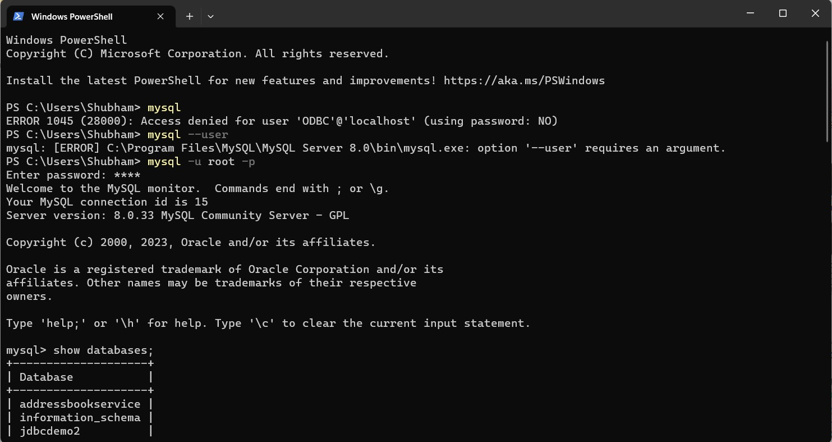

**Before the crud operations one needs to run following commands in the terminal to create a database.**

* **create database [databasename];**
* **use [databasename];**

**MySQL CRUD Operations:**

**CRUD stands for Create, Read, Update, and Delete. These are the four basic operations that can be performed on data in a MySQL database using SQL commands.**

* **Create: This operation is used to insert new records into a database table. The SQL command used for this is INSERT INTO, followed by the name of the table and the values to be inserted.**

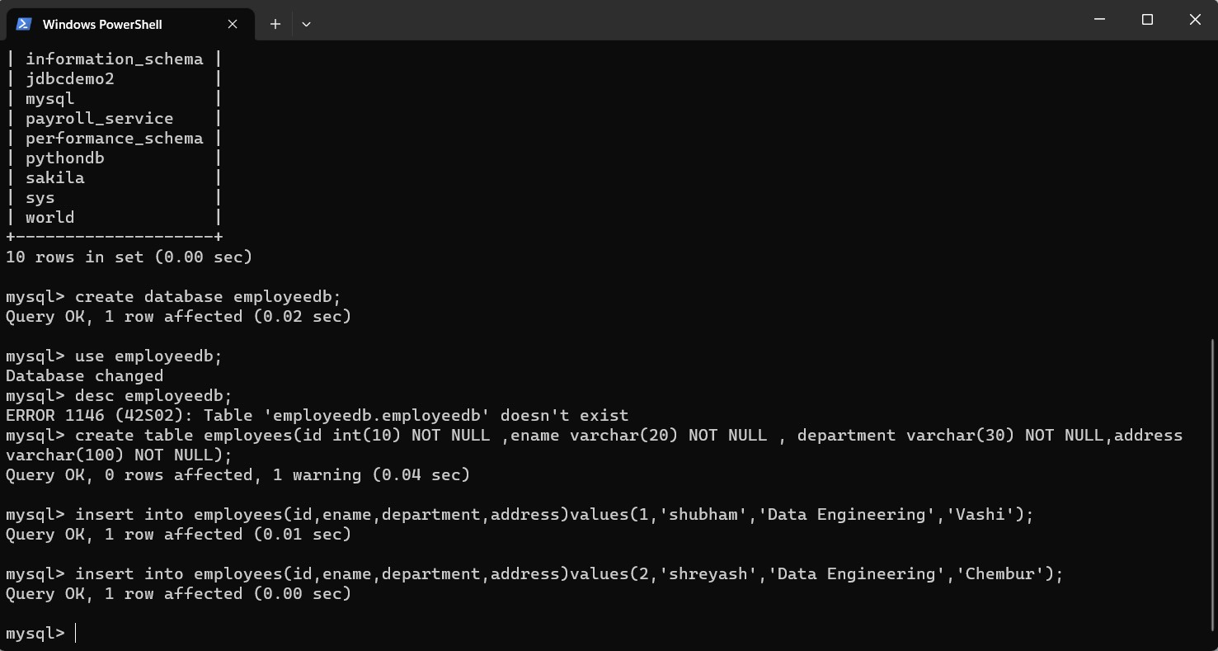

* **Read: This operation is used to retrieve data from a database table. The SQL command used for this is SELECT, followed by the columns to be retrieved and the name of the table.**

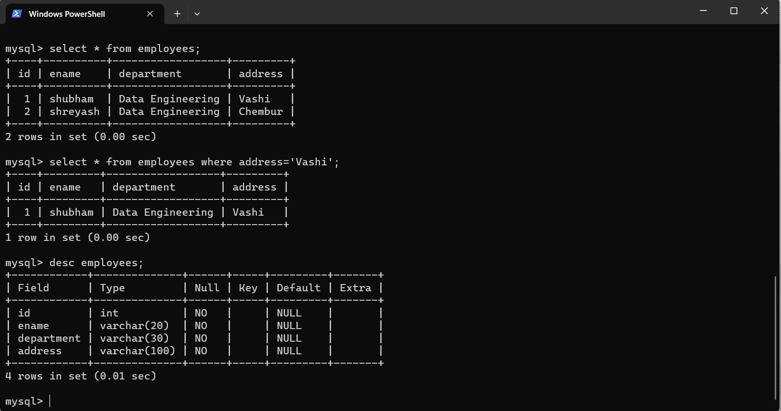

* **Update: This operation is used to modify existing records in a database table. The SQL command used for this is UPDATE, followed by the name of the table, the columns to be updated, and the new values.**

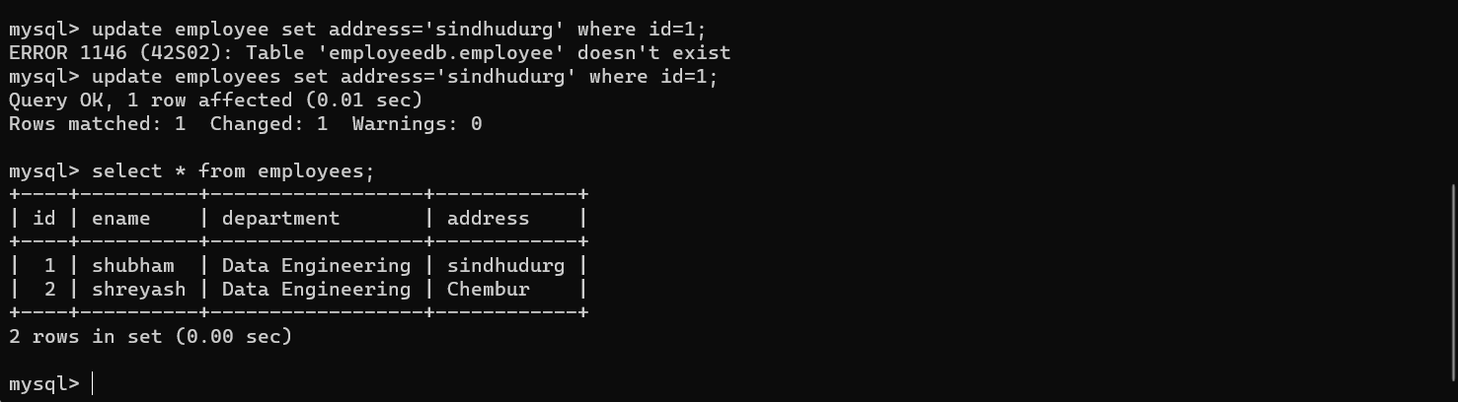

* **Delete: This operation is used to remove records from a database table. The SQL command used for this is DELETE FROM, followed by the name of the table and the condition that must be met for the record to be deleted.**

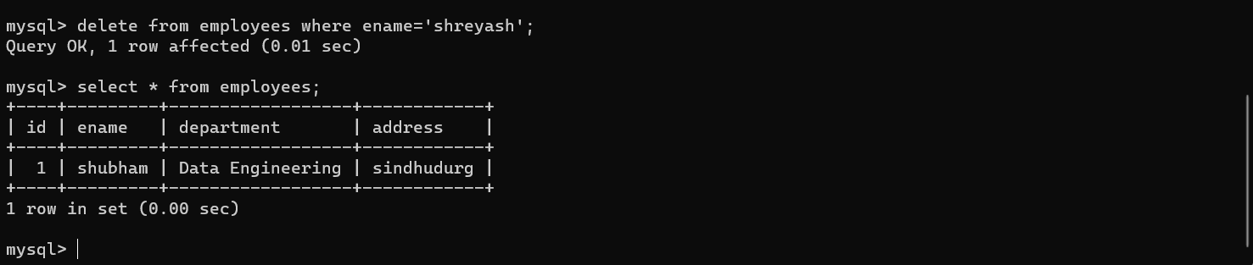

**Export SQL File:**

**Terminal Command**

**mysqldump -u <username> -p <database_name> > <output_file.sql>**

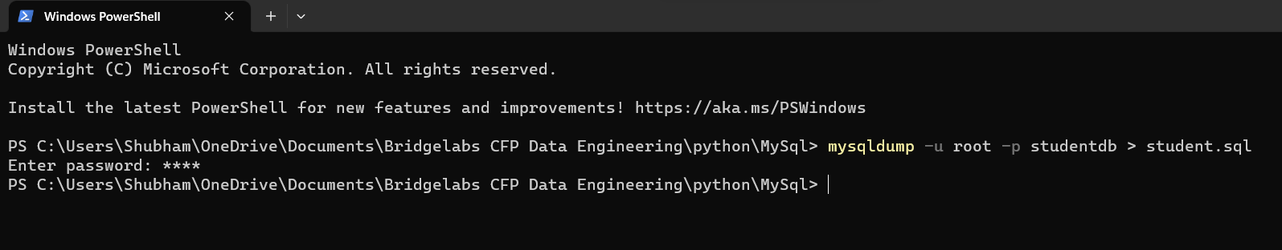

**Import SQL File from terminal:**

**Terminal command:**

**Note: < is not available in powershell. Use system terminal**

**mysql -u <username> -p <database_name> < <input_file.sql>**

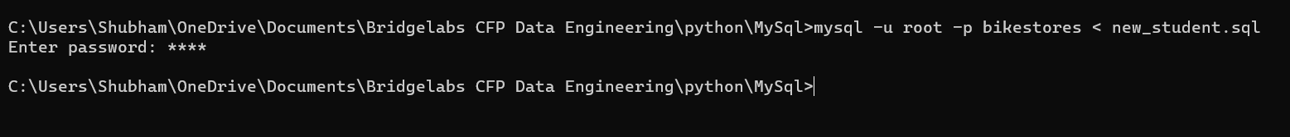

**Export Particular SQl Table**

**mysqldump -u <username> -p <database_name> <table_name> > <output_file.sql>**

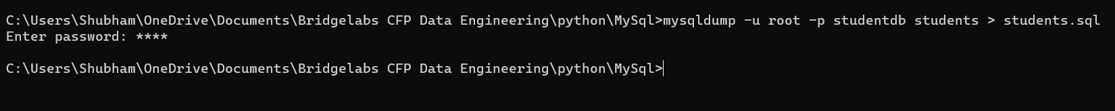

**Workbench:**

**Export -**

**Administrator**

**Data Export**

